**Exercise 3: Implementing Logging with Spring AOP**

**Scenario:**

**The library management application requires logging capabilities to track method execution times.**

**Steps:**

**1. Add Spring AOP Dependency:**

**o Update pom.xml to include Spring AOP dependency.**

**Ans.**

I have updated to pom.xml file and included spring AOP dependence

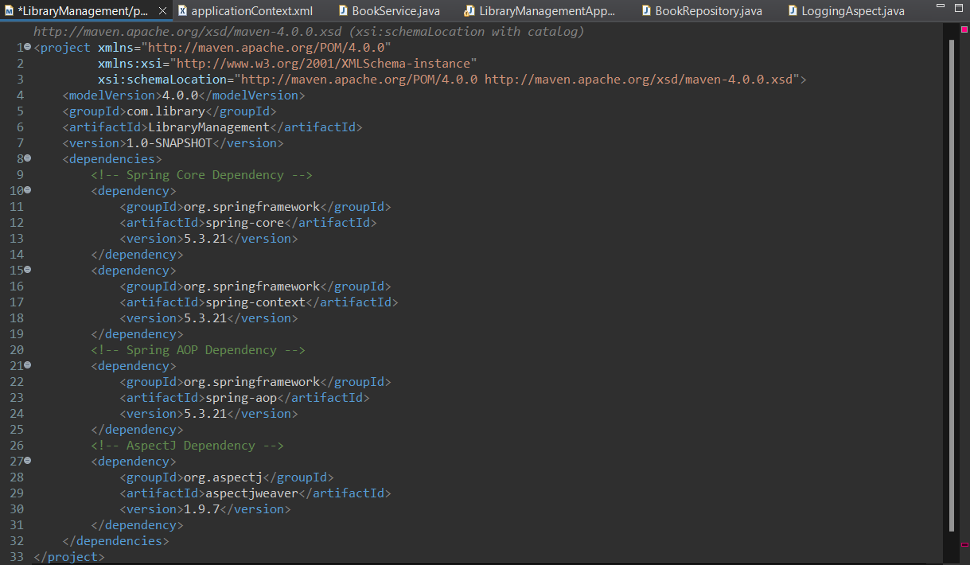

**2. Create an Aspect for Logging:**

**o Create a package com.library.aspect and add a class LoggingAspect with a method to log execution times.**

**Ans.**

Step 1: -Right-click on src/main/java and select New > Package.

Step 2: - Enter com.library.aspect as the package name and click Finish.

Step 3: - Right-click on the newly created package and select New > Class.

Step 4: - Enter LoggingAspect as the class name and click Finish.

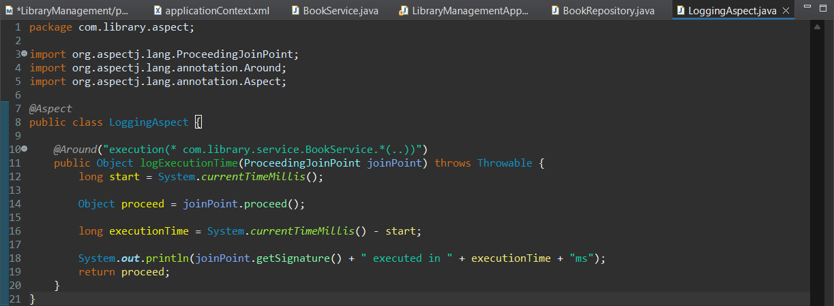

**3. Enable AspectJ Support:**

**o Update applicationContext.xml to enable AspectJ support and register the aspect.**

**Ans.**

I have updated the applicationContext.xml and enabled AspectJ support and registered the aspect.

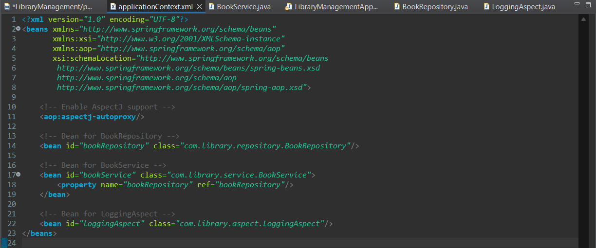

**4. Test the Aspect:**

**o Run the LibraryManagementApplication main class and observe the console for log messages indicating method execution times.**

**Ans.**

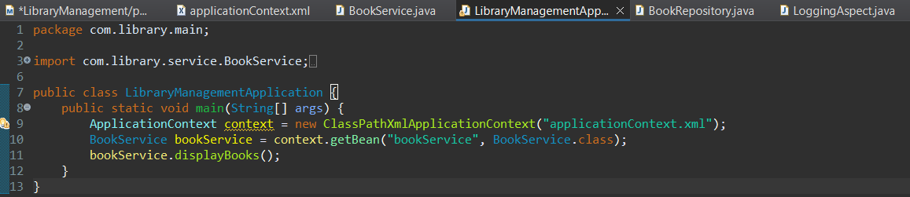

**Output: -**

